**Project Documentation:**

**Railway Ticket & Journey Analysis**

**David Hany**

**Taha Mohamed**

**Mohamed Jalag**

**Omar Sherif**

**Mohamed Hossam**

**1. Project Planning & Management**

**1.1 Project Proposal**

This project aims to analyze railway ticket purchases, journey details, and travel delays using a dataset of 31,653 records. The objective is to gain insights into passenger behavior, ticket pricing, and factors affecting journey delays. The analysis will support railway operators in improving operational efficiency and customer satisfaction.

**1.2 Project Plan**

* **Timeline:**
  + Data Collection & Cleaning: 2 weeks
  + Data Analysis & Visualization: 3 weeks
  + System Design & Implementation: 4 weeks
  + Testing & Final Documentation: 2 weeks
* **Milestones:** Data cleaning, exploration analysis, model development (if applicable), and final reporting.
* **Deliverables:** Comprehensive analytical reports, visualizations, and system documentation.
  1. **Task Assignment & Roles**
* **Data Engineer:** Data preprocessing and cleaning.
  + **Taha Mohamed**
* **Data Analyst:** Exploratory data analysis and visualization.
  + **David Hany**
* **System Architect:** Database and system design.
* **Project Manager: Documentation** and report compilation.
  + **David Hany**
  + **Taha mohamed**

**1.4 Risk Assessment & Mitigation**

* **Risk:** Missing or inconsistent data.
* **Mitigation:** Implement data imputation and validation techniques.
* **Risk:** Large dataset processing challenges.
* **Mitigation:** Use optimized data handling techniques

**1.5 Key Performance Indicators (KPIs)**

* Total number of transactions processed.
* Percentage of delayed journeys.
* Average delay time for affected journeys.
* Ticket sales trends by category and location.

**2. Literature Review**

**2.1 Feedback & Evaluation**

A comparative study of railway ticketing and delay analysis methodologies was conducted. The existing research highlights predictive analytics as a key tool in optimizing railway operations.

**2.2 Suggested Improvements**

* Enhancement of data accuracy through better logging mechanisms.
* Implementing predictive analytics to foresee and mitigate delays.

**2.3 Final Grading Criteria**

* Documentation: 30%
* Implementation: 30%
* Testing & Validation: 20%
* Presentation & Reporting: 20%

**3. Requirements Gathering**

**3.1 Stakeholder Analysis**

* **Railway Operators:** Improve service efficiency and optimize routes.
* **Passengers:** Gain insights into travel patterns and potential delays.
* **Government Authorities:** Support infrastructure and policy planning.

**3.2 User Stories & Use Cases**

* **User Story:** As a passenger, I want to know the probability of delays before purchasing a ticket.
* **Use Case:** Utilize past journey data to predict and alert potential delays.

**3.3 Functional Requirements**

* Process and analyze railway ticket purchase data.
* Identify common delay patterns.
* Provide visualized reports on travel efficiency.

**3.4 Non-Functional Requirements**

* Ensure data security and privacy.
* Optimize query performance for large datasets.
* Maintain high system availability and reliability.

**4. System Analysis & Design**

**4.1 Problem Statement & Objectives**

This project aims to enhance railway service reliability by leveraging data analytics to uncover travel trends and delay patterns.

**4.2 Database Design & Data Modeling**

* **ER Diagram:** Represents ticket transactions, customer details, and journey logs.

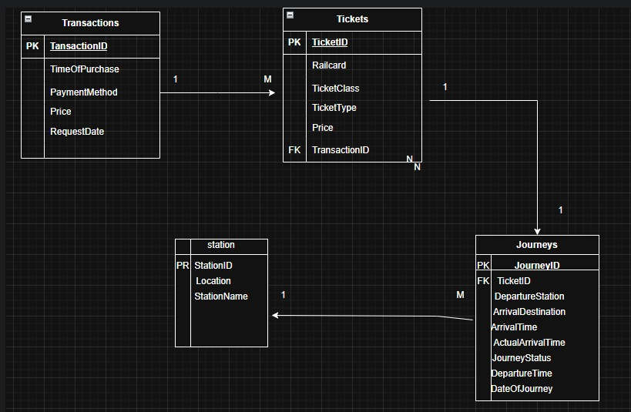

* 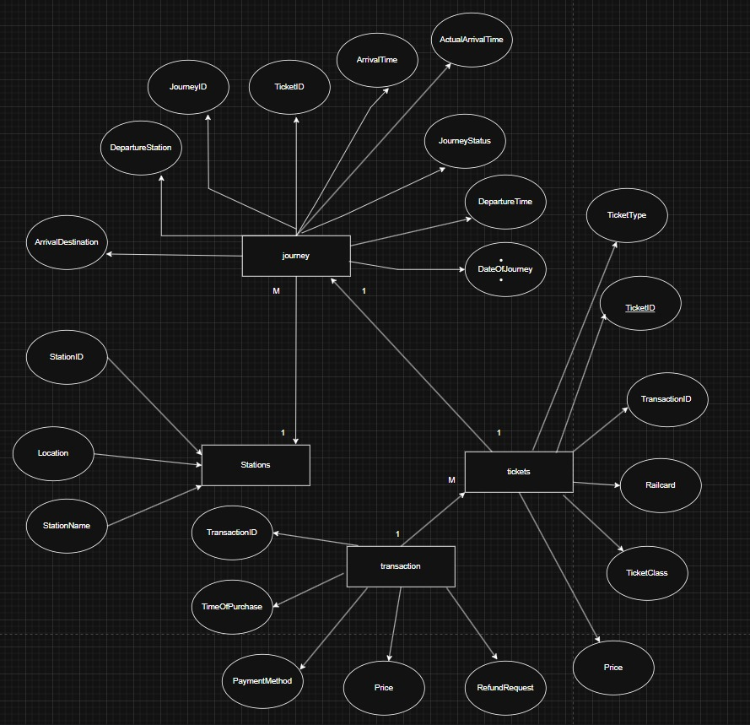**Logical Schema:** Tables for transactions, ticket types, payment methods, and journey records.

**4.3 Data Flow & System Behavior**

* **Data Flow Diagram (DFD):** Illustrates ticket purchases and journey tracking.

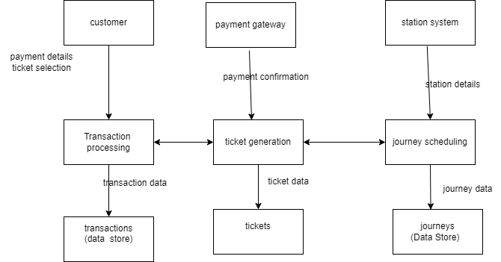

* **Sequence Diagram:**

* **State Diagram:**

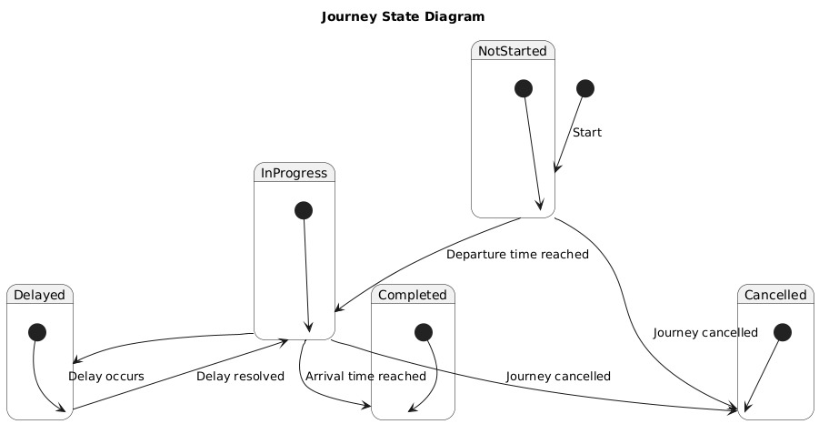

* 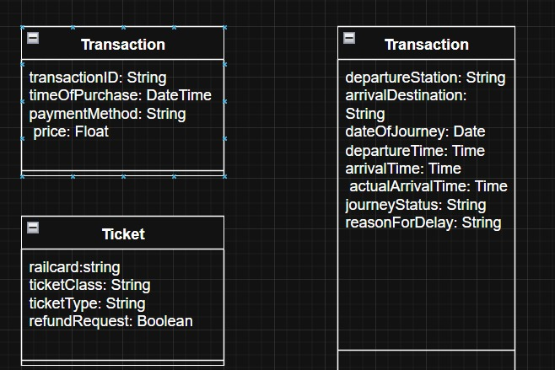**Class Diagram:**

**4.4 UI/UX Design & Prototyping**

* **Wireframes & Mockups:**
* **UI/UX Guidelines:**

**4.5 System Deployment & Integration**

* **Technology Stack:** Python (Pandas, Matplotlib), SQL database, web-based visualization.
* **Deployment Diagram:** Cloud-based or local execution model.
* **Component Diagram:** High-level system components and their interactions.